Test Execution Log and Screenshots

|  |  |
| --- | --- |
| Test Id_Name | Cyclos01_Login into Cyclos with valid credentials |
| Workflow | Default |
| Shared DataSet | Cyclos |
| Test DataSet |  |
| Execution Date & Time |  |
| Test Status | Passed |

Step Name: Chrome::Cyclos01::Default::Cyclos::-1

Step Description: Open Cyclos application

Expected Result: Cyclos application is opened

Actual Result: Application 'https://demo.cyclos.org/' is launched.

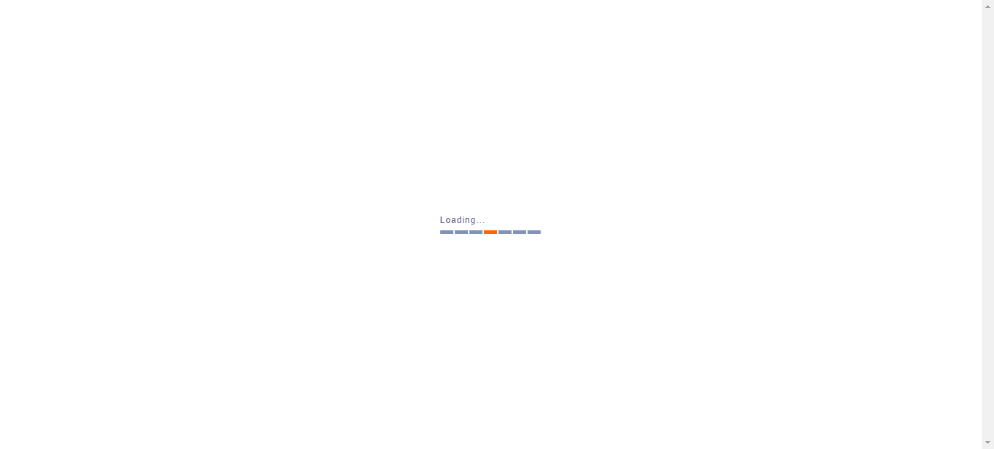

Step Name: Chrome::Cyclos01::Default::Cyclos::-2

Step Description: Click Sign-In link

Expected Result: Sign-In link is clicked

Actual Result: Link 'Sign In' in the screen 'Cyclos -> Pre login' is clicked.

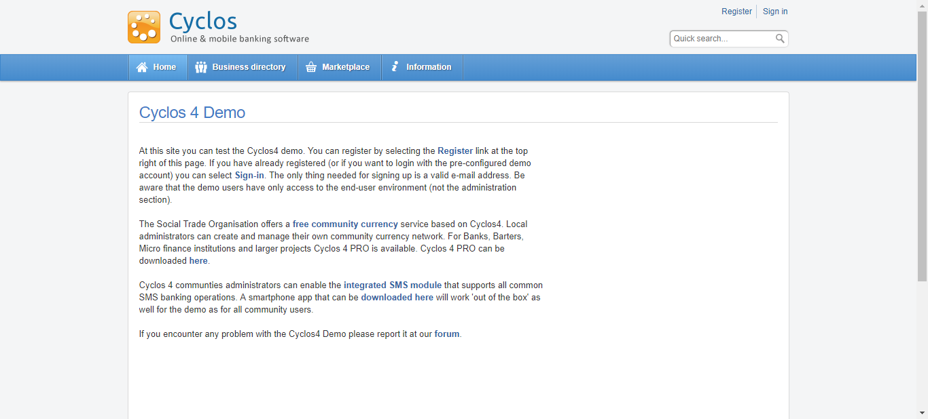

Step Name: Chrome::Cyclos01::Default::Cyclos::-3

Step Description: Enter Username

Expected Result: Username entered

Actual Result: Value 'demo' is entered in the field 'Username' of the screen 'Cyclos -> Login'.

Step Name: Chrome::Cyclos01::Default::Cyclos::-4

Step Description: Enter Password

Expected Result: Password entered

Actual Result: Value '1234' is entered in the field 'Password' of the screen 'Cyclos -> Login'.

Step Name: Chrome::Cyclos01::Default::Cyclos::-5

Step Description: Click Login

Expected Result: Login button is clicked

Actual Result: Button 'Login' in the screen 'Cyclos -> Login' is clicked.

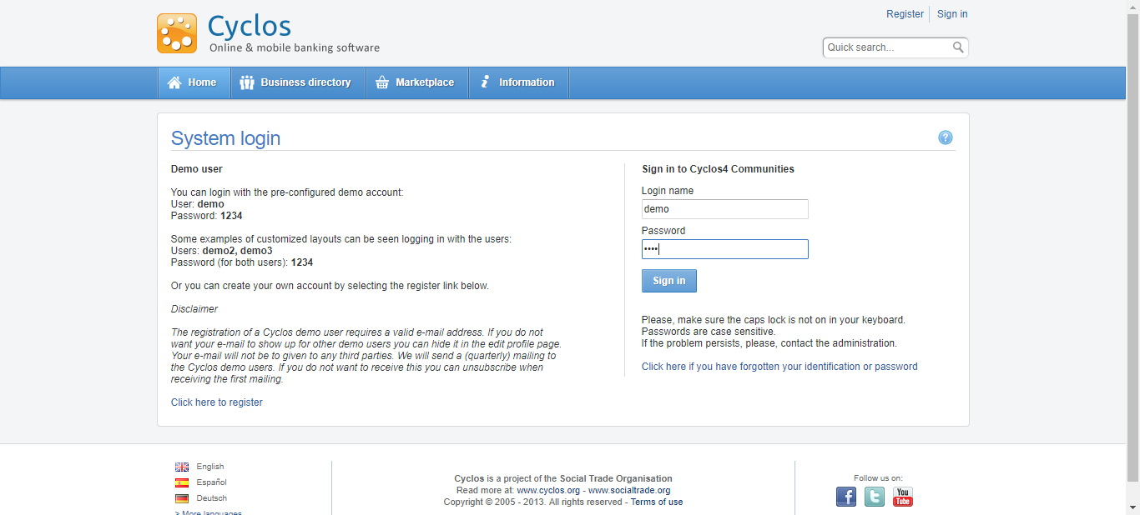

Step Name: Chrome::Cyclos01::Default::Cyclos::-6

Step Description: Verify if the Account home page is displayed

Expected Result: Account home is displayed

Actual Result: The field 'MyAccount' is present in the screen 'Cyclos -> Home'.

